Reporting Project Topic: Business Growth Storyboard (Tableau)
Abstract – Overall:
The Indian service team is working for US health insurance on four projects: Medicare, Commercial, Individual Enrollment, and Billing. This project analyses the Health Operations data for two years (2023, 2024) on a quarterly basis to assess their project performance across all teams.
Problem statement:
In health operations, multiple service projects have been working on the same deal. Projects are Medicare, Commercial, Individual Enrollment and Billing. These projects’ clients live in the USA. The service team is in India. The service team does not have data integrated into one platform. Data is maintained by each team separately. So, they find it difficult to accumulate all the project’s data at once. Because the client will be visiting next week, they should prepare all the data in one tool to present their achievements and business updates across the teams.
Objective – Reason:
The Tableau tool is the best for a storyboard/presentation to tell their team's performance, achievements, and employees’ contributions to the client visits. So the client can easily understand visually how they are working and managing their projects.
Existing System – Previous:
Disadvantages: They are maintaining records separately on all teams. Whenever they need combined data, they need to collect data from all teams and clean it up for the presentation at the time of the requirement. It is time-consuming to collect data and consolidates together.
Proposed system – Current /Upcoming
Advantages: Proposed to maintain the data every day in a database or Excel for all teams' data in one tool. So it can save time and prevent collecting data from each team when it is required. Whenever the client needs, we can use a tool to collect updated data and use the BI tool for presenting the insights.
Modules Used: Dataset – Source: Claude (Health Operations ticket-based dataset)
Tools:
- MS Office Excel 2021 for data review and understanding.
- Tableau is used for developing a presentation regarding ticket processing performance, revenue generation and customer satisfaction insights with all four teams.
Methodology – Overall workflow:
- Understand the project issue and requirements. Documented as a core problem, created an own example (Health Operations Project) set of a problem statement and solution.
- Data collected from the Claude source in CSV; file converted to Excel.
Tableau:
- In Tableau, imported Excel data and created different combinations of charts: Ticket raised vs resolved count, SLA target hours vs actual resolution hours, Revenue, Priority vs Status count, Key insights, KPI for Revenue, SLA%, Avg CSAT score%.
- Created calculation fields for SLA%, Avg CSAT%, Resolution rate and Backlog rate, and ticket category based on status.
- Ticket category: Resolved, Closed, and Escalated status are completed. Pending Review, Open and In Progress are backlogs.
- Separate fields of filters included: overall team name, ticket status, SLA met and Client managers of all teams.
- All these charts, KPI and filters are arranged in the dashboard; the floating method is used for the container.
- PPT has been created for presentation in the project review.
Conclusion – Project view:
The project was developed to find insights into all four projects' performance metrics with two years of data (2023 and 2024) in quarter basis. They can visually see how many tickets were received and completed, SLA met or not as per targeted hours, KPI, and the revenue of each team, as well as the count of priority tickets and the status of the tickets.
Result - End Declaration:
The dashboard shows the service team has an equal backlog and completed tickets in all four projects. Most of the tickets were processed beyond the SLA target hours; those are not meeting the SLA. These are the biggest instabilities in the production side.
Future Improvement – Additional Features to work:
- Should hire new employees to support processes to complete the backlog ticket.
- SMEs should deliver the training to the onboard employee and refresher training to the existing employees who have not met the SLA.
- Perform overtime work to complete the backlog.
- Declare award recognition to the employees who have good performance on a quarter-wise basis. So that other employees get motivated to achieve the production goal.
Output – Screenshot:
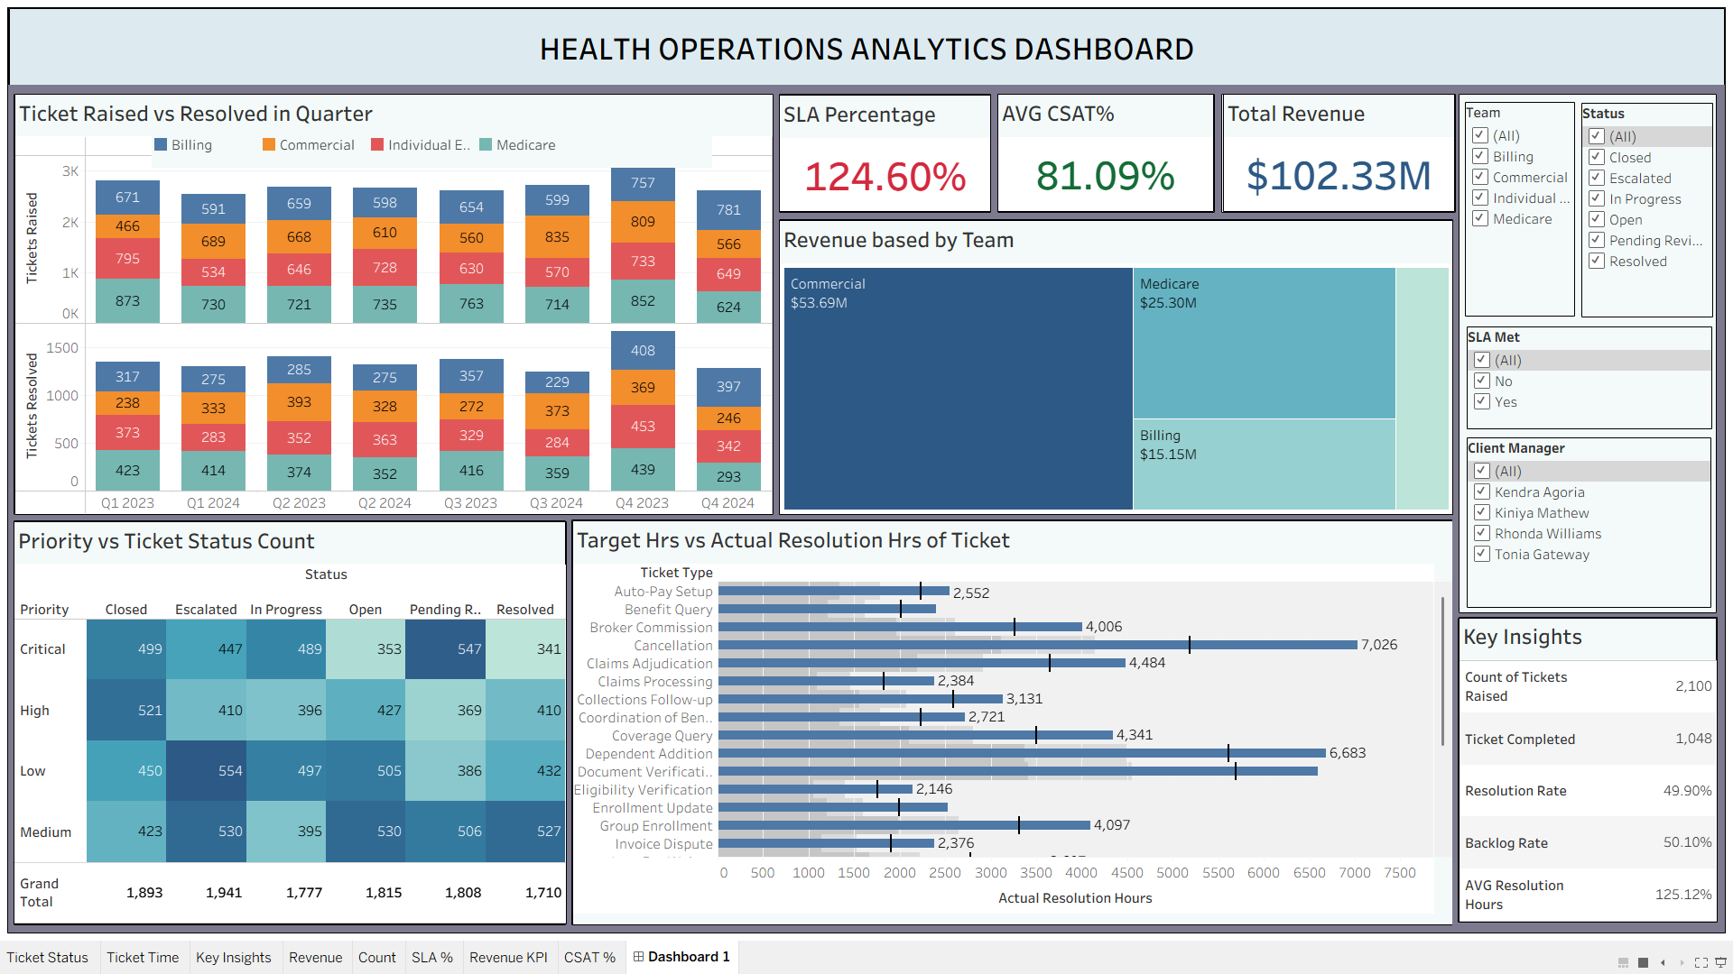
Reference:
- Claude – For dataset collection.
- Google Gemini – For calculating field formulas to create resolution rate, backlog rate, avg CSAT score and SLA%.

